Project Summary

The project goal was to help Seattle Department of Transportation (SDOT) in their process of developing a bike sharing system as they review their recent pilot program. We explored open source data sets from the bike sharing systems of Chicago, Los Angeles, and Washington, D.C. to determine characteristics of bike sharing programs in other U.S cities.

Bike sharing is a short term bicycle rental system. A user picks up and rents a bike from a station, uses it for as long as they need, and then return it to the same or a different station. Most systems have membership options but typically allow non-members to use the bikes.

Our audience is SDOT, particularly the director of the department and financial decision makers. We identified several key factors of bikeshare systems: number of bikes in the fleet, popular routes and stations, busiest times of day, impact of weather, and usage by different demographics.

The bikeshare data comes from the respective transportation municipalities of Chicago, Los Angeles, and Washington, D.C. for April, May, and June (Quarter 2) of 2018. All three municipalities posted these datasets under an open-source license. Processing entailed renaming column names to be congruent, converting the duration from seconds into hours and minutes, and removing any blanks or null cells.

The weather data comes from Weather Underground, a website owned by IBM Business. The historical data comes from recordings at weather stations and is provided in text tables. We converted these tables into a .csv format so they could be analyzed in R Studio.

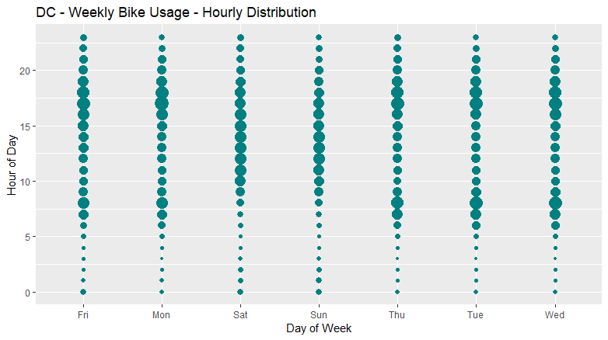

This plot displays aggregated ridership over time in Washington, D.C. over the study period. The x-axis is the day of the week and the y-axis is the time of day, where 0 = midnight. Each bubble represents the number of rides taken during that hour. A larger bubble means more bikes were rented during that hour. On weekdays, ridership is highest in the morning and evening commute times. On weekends, ridership grows and then remains relatively stable during daylight hours, from about 10 am to 7 pm. This information can help Seattle determine how many bikes need to be available at what times. This can help inform repair schedules and factor into how many bikes should be in the fleet.

Another important analytical result is the top five most popular start and end stations in each study we studied. Based on number of rental initiations and rental terminations, we determined the stations that users visit most often. After mapping these using the Google map making tool, we determined that the most popular stations are near tourist attractions and transit centers such as train stations. This knowledge, combined with the knowledge that ridership increases during morning and evening commutes and during weekend daylight hours, it will be important for Seattle to have enough bikes at major attractions and transit hubs. Based on Trip Advisor ratings, we suggest the Seattle Space Needle, King Street Train Station, Pioneer Square, and Chihuly Garden and Glass Museum.

Word Count: 500